ANA502 Final data preparation
KOHEI NISHITANI

- Basic Data Understanding
The dataset includes 1287 listings in April 2025 with 41 features.

1.1 Distribution of each columns
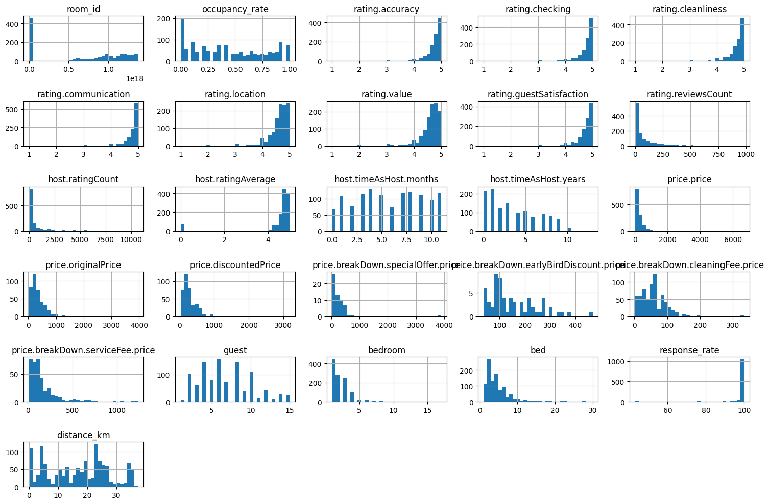

1.2 Correlation Matrix
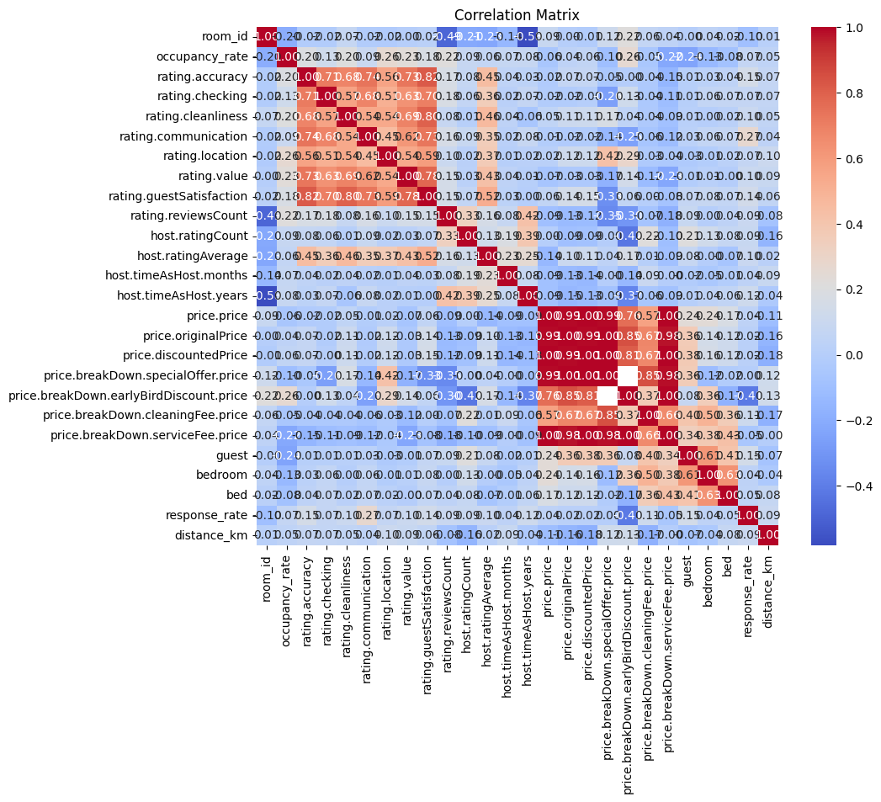

  - Occupancy rate(Target variable) distribution
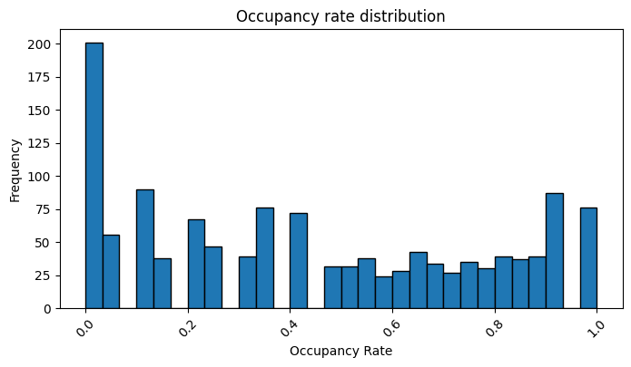

2.1 Highly correlated variable visualization
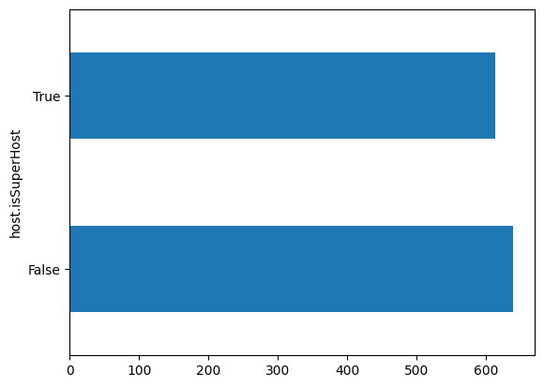

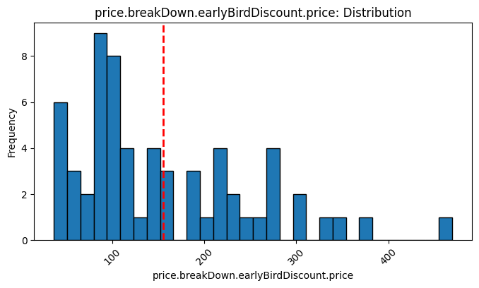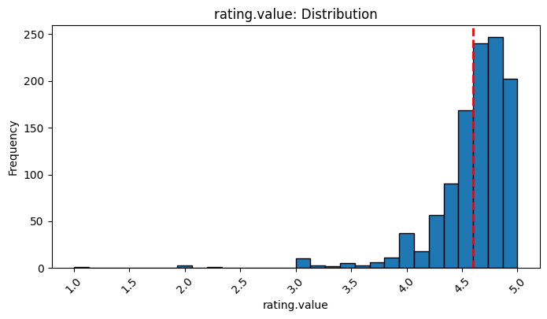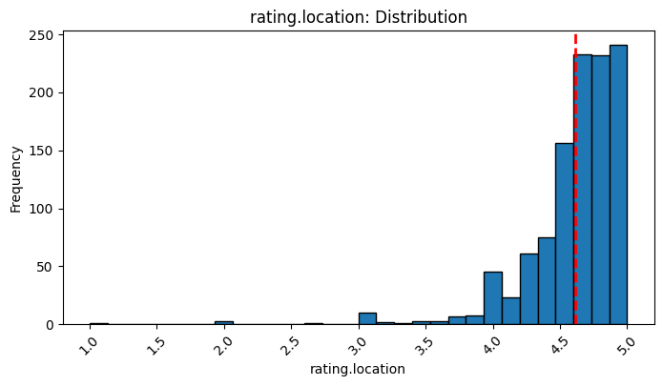

3.1 Simple Linear Regression
